**City University of Hong Kong**

CS3343 Software Engineering Practice

Test Report

Project Title: Club Management System

**Group**: 2 **Tutorial** **Session**: L01

|  |  |
| --- | --- |
| **Name** | **Student Number** |
| WANG KA CHUN KEVIN | 55229123 |
| WONG SIU FAI | 55223247 |
| HO KWAN TO | 55233726 |

The following is our hierarchy diagram:

Methodology

We choose the Top-Down Approach as our testing method. Testing takes place from top to down following the control flow of the software system. A higher possibility of obtaining an early prototype is one of the reasons we use this approach. To ensure that we can start as soon as possible, we have to use the Top-Down method to get our first image of the prototype. Moreover, when it comes to the Top-Down Approach, critical Modules are tested on priority; major design flaws could be found and fixed first, for example, main and some other essential commands. Therefore, it would be a smart decision to use the Top-Down method.

**Unit Testing**

* Unit Testing 1: Main

**Integration Testing**

* Integration Testing 1: Main + Command (e.g. AddClubTutorCM, CreateClubCM,etc,)
* Integration Testing 2: Main + Command + School

**System Testing**

* Main + Command + School + Teacher + Club

Coverage Analysis

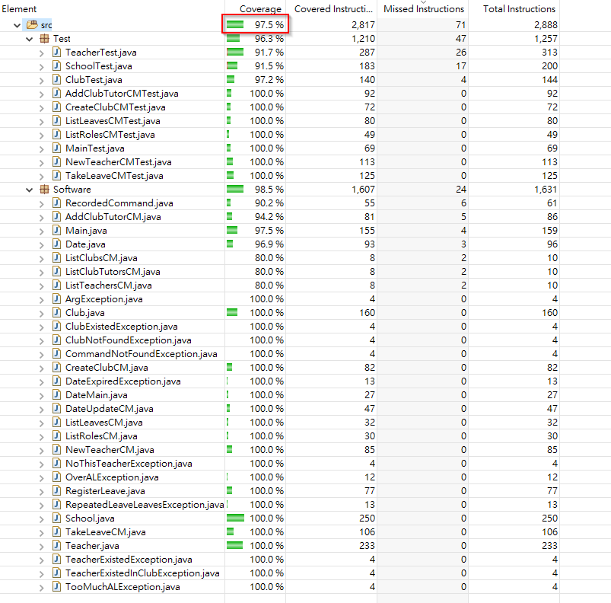

We tried our best to achieve the highest percentage for full coverage of testing, and it is 97.5% in the end.

Details

**Main.java**

|  |
| --- |
|  |

**Teacher.java**

|  |
| --- |
|  |

**School.java**

|  |
| --- |
|  |

**Club.java**

|  |
| --- |
|  |

**AddClubTutorCM.java**

|  |
| --- |
|  |

**CreateClubCM.java**

|  |
| --- |
|  |

**ListLeavesCM.java**

|  |
| --- |
|  |

**ListRolesCM.java**

|  |
| --- |
|  |

**NewTeacherCM.java**

|  |
| --- |
|  |

**TakeLeaveCM.java**

|  |
| --- |
|  |